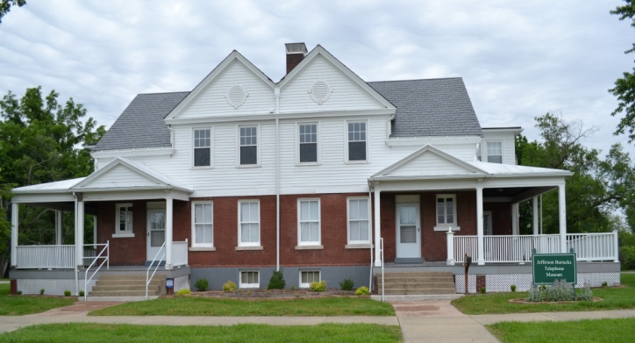
Jefferson Barracks Telephone Museum

Open Wednesday – Sunday 9 a.m. – 2 p.m.

12 Hancock Avenue, St. Louis MO 63125
314.416.8004 facebook.com/jbtelmuseum

The Jefferson Barracks Telephone Museum is housed in a beautifully restored 1896 building that is on the National Register of Historic Places. It is located in the 426-acre historic Jefferson Barracks Park which is a 15 minute drive south of downtown St. Louis.

Members of the Telecom Pioneers, a non-profit 501(c)(3) telephone company employee service organization, and their families and friends have spent over 66,500 hours in repairing and renovating the building.

The self-guided, accessible museum has many hands-on, how-things-work displays. The displays were created to inspire an interest in engineering and history. Boy Scouts can utilize the museum to meet one of their Inventing and Engineering merit-badge requirements.

Besides its extensive collection of telephones manufactured from the late 1880s through 2000s, the Jefferson Barracks Telephone Museum also contains:
- A working Central Office Step Switch.
- Operator switchboards from the 1920s and 1960s.
- Military telephones from WWI through the Vietnam War.
- Hundreds of telephone-related equipment and tools.
- A telephone pole complete with climbing equipment.
- Hundreds of pieces of telephone-related memorabilia.
- A large variety of novelty telephones.
- A sculpture of Alexander Graham Bell and history of the invention of the telephone.

Admissions: Adults - $5 Children Ages 5 to 12 - $3
Seniors Age 60 and older - $4 Children Age 4 Years and Younger – Free
Active Military Members – Free

Guided tours are available for groups of 10 or more and should be scheduled at least two weeks before the tour. Groups of 10 or more each receive $1 off their admission.

Enjoy nostalgia from the early years of the telephone. It’s a fun family adventure,
an educational field trip for students and an enjoyable group outing.

JEFFERSON BARRACKS TELEPHONE MUSEUM
COMPRESSED PHOTOGRAPHS

Jefferson Barracks Telephone Museum Building

Jefferson Barracks Telephone Museum Logo
